CandidateName

Table as per design

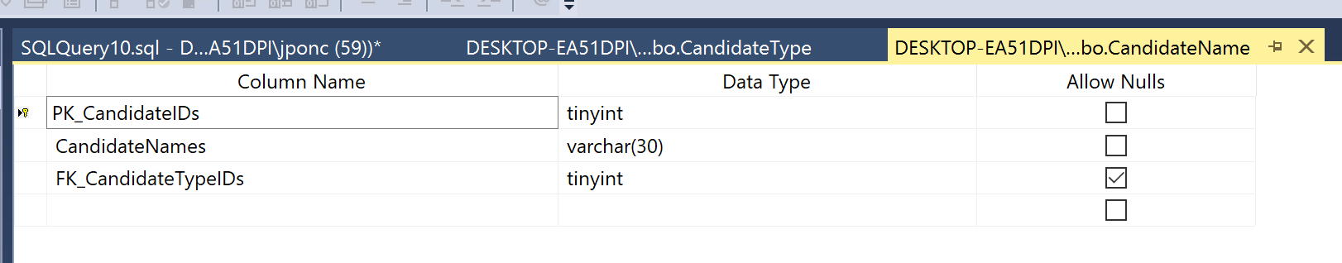

Rows retrieved 131 rows

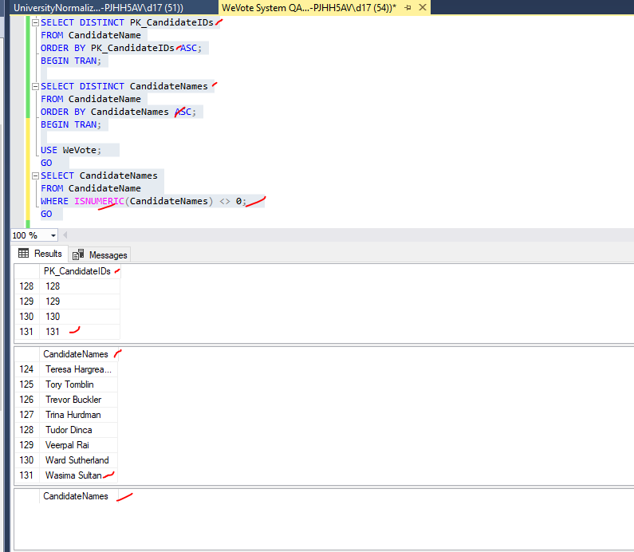

**Dec. 21, 2020**

1. CandidateName:

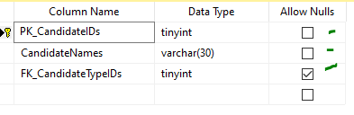

* Validate if records can be inserted into current PK--

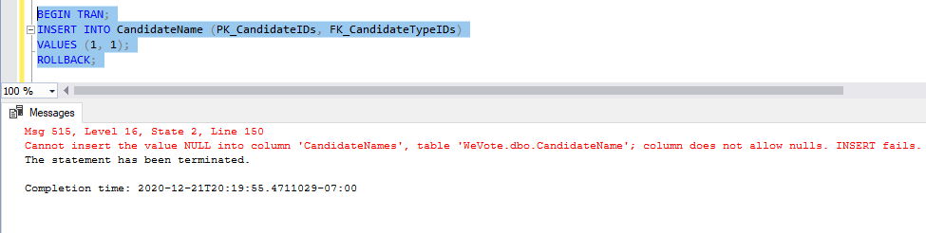

* + Validate if records can be updated using current PK—

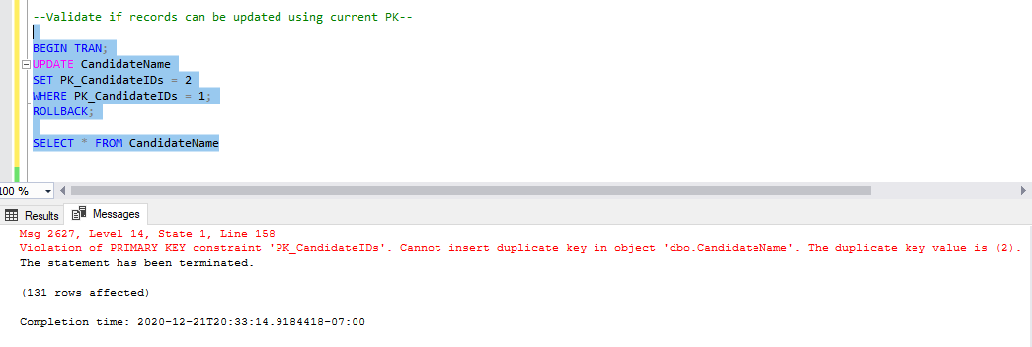

* + Validate if non-existent record can be retrieved

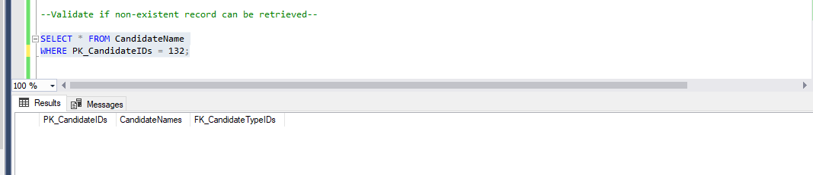

* + Validate if Primary Key not related to Foreign Key

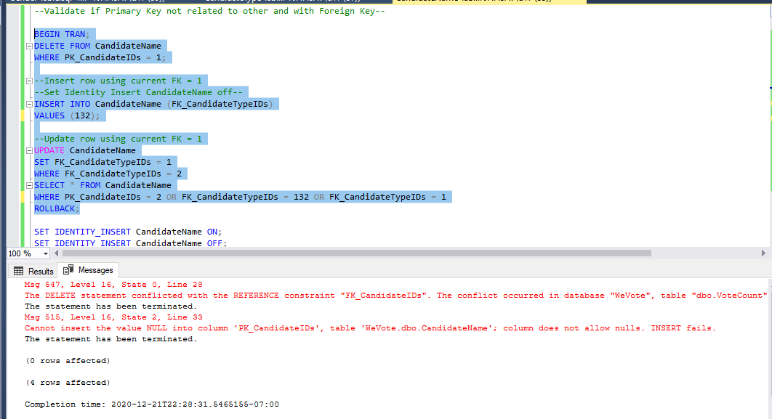

* + Validate if PK not Null constraint

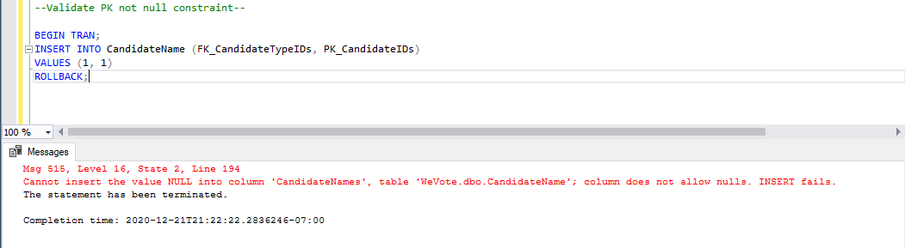

* + Validate if a null PK can be updated

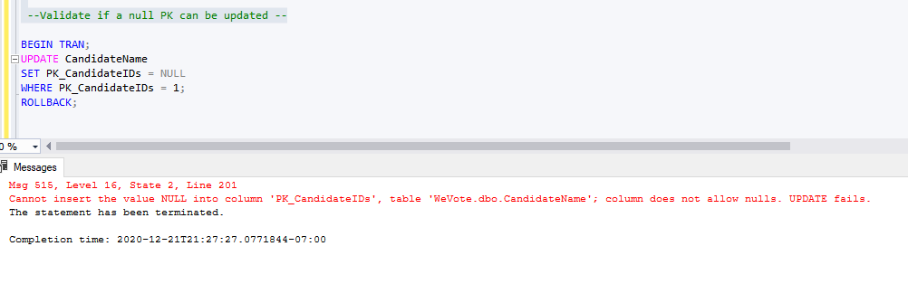

* + Validate CandidateName > NOT NULL constraint>When: Undefined Candidate Name >is added >Then:Insert nor update is not allowed (NOTE: Just curious, to double check PK and FK)

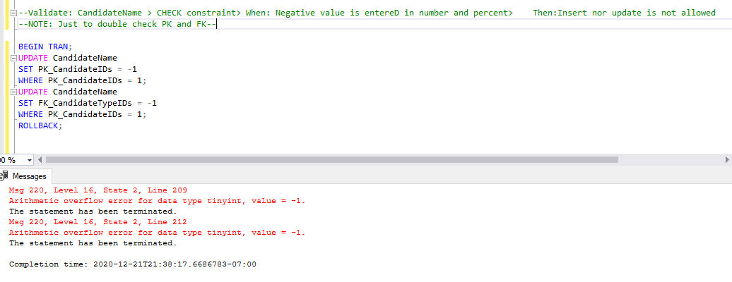

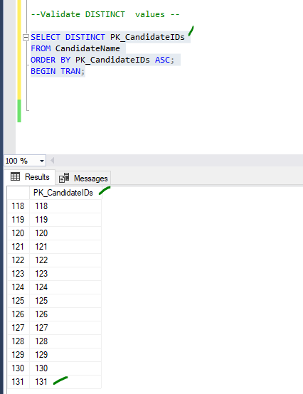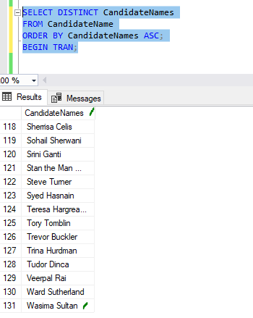

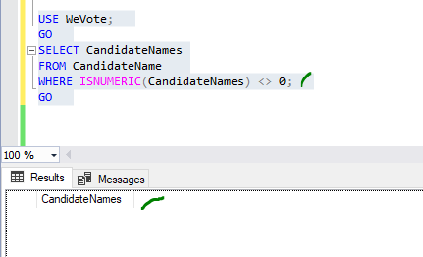

Data Manipulation

Primary Key not related to other table and with Foreign Key

